Sagar Public School, Saket Nagar, Bhopal



**A**

**Practical Record**

**On**

**Informatics Practices**

**(Python & MySQL)**

Session: 2019 – 2020

**Submitted to:**

**Mr. Vinod Kumar Singh**

**PGT (IP)**

Submitted by:

________Ojas_Aklecha________

Class XI B

Sagar Public School, Saket Nagar, Bhopal



**A**

**Project Record**

**On**

**__________College Admission Management System__________**

**(Informatics Practices)**

Session: 2019 – 2020

**Submitted to:**

**Mr. Vinod Kumar Singh**

**PGT (IP)**

Submitted by:

___________Ojas Aklecha_____________

Class XI B



**Python** Programming Language is a high-level and interpreted programming language which was created by **Guido Van Rossum** in **1989**. It was first released in **1991**, which results in a great general purpose language capable of creating anything from desktop software to web applications and frameworks.



**MySQL** is an Oracle-backed open source relational database management system (**RDBMS**) based on Structured Query Language (**SQL**). MySQL runs on virtually all platforms, including Linux, UNIX and Windows. ... MySQL is an important component of an open source enterprise stack called **LAMP**.

Insert Function–Through this option we can insert new data into our database.

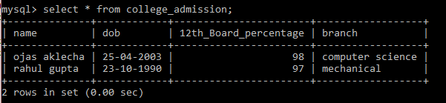

**Initial Records**

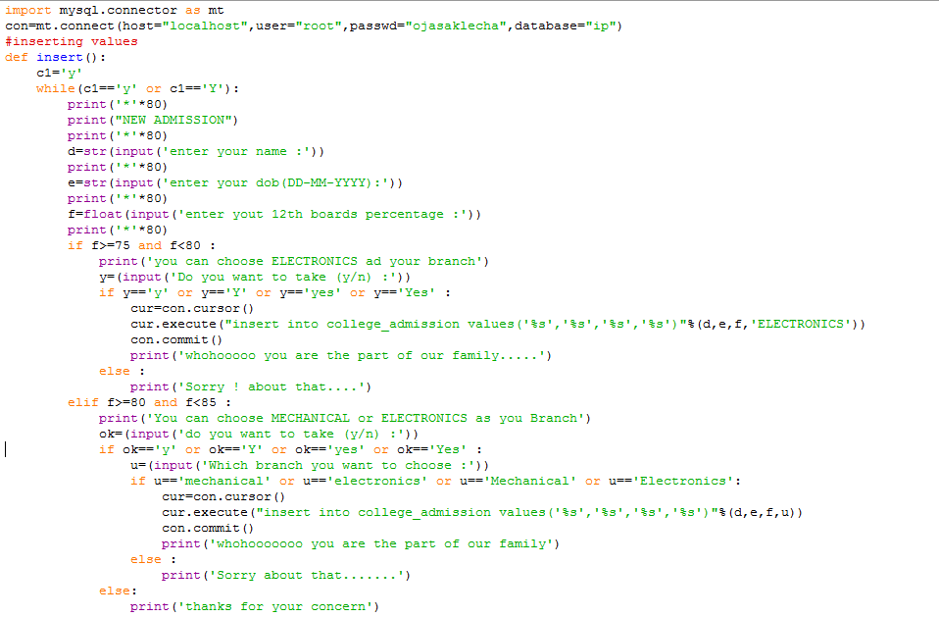

**Code In Python**

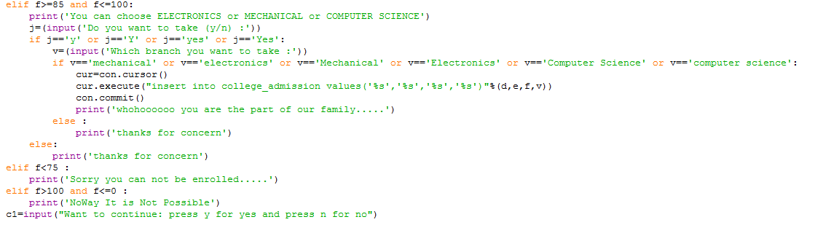

**Code In Python**

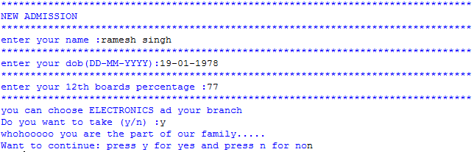

**Output In Python**

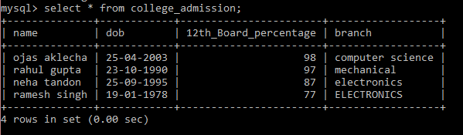

**Output In MySql**

**Display Function – This function is use to display all the existing data in out database.**

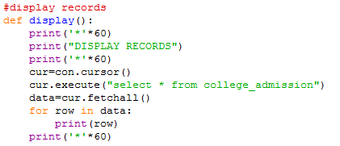

**Code In Python**

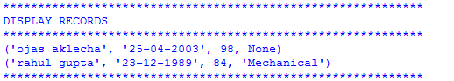

**Output In Python**

**Delete Function – This function is used to delete record from the database.**

**C:\Users\Ojas\Desktop\college admission ip 11th project\Initial Records Delete.PNG**

**Initial Records**

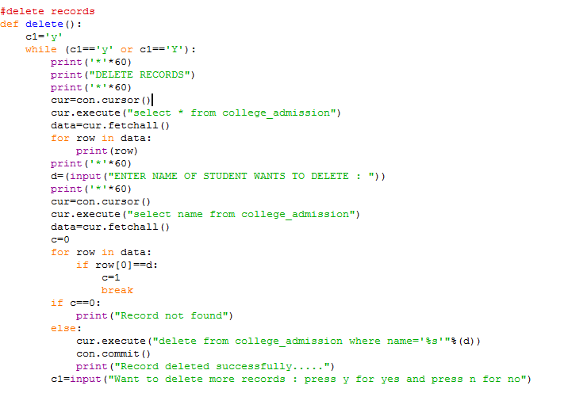

**Python Coding**



**Python Output**

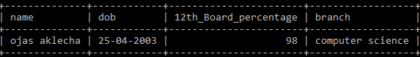

**MySql Output**

**Thank You**